Cherokee Scout Reservation
Cracker Barrel Options for Units

Interested in hosting a special cracker barrel in your campsite for your unit one night during summer camp? Cracker barrels will be delivered to the campsite. Cracker barrel opportunities are available Monday, Tuesday, Wednesday, and Friday evenings. Cracker barrels will be delivered to the campsite at approximately 9:15 pm (alternative times can be arranged).

Item | Description | Unit Cost | Image
Option 1: Jolly Rancher Bomb Pop | The three most popular Scout-inspired flavors of Strawberry, Blue Raspberry and Watermelon come together in Candy Clash to deliver an unbeatable cool experience on a popsicle stick. | $2.00 ea
Option 2: Blue Bunny Ice Cream Sandwich Chips Galore | Blue Bunny Chips Galore!® cookie sandwich piles on the chocolate chips, with creamy vanilla flavored frozen dairy dessert layered between two chocolate chip cookies and rolled in mini chocolate chips. 4.5 oz | $3.00 ea | 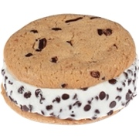
Option 3: Ice Cream Float | Cola poured over vanilla soft serve ice cream makes a refreshing chilled beverage to help you cool down at the end of the day. Floats come in a 12oz plastic commemorative cup. | $4.00 ea | 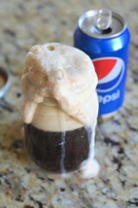
Option 4: Ben & Jerry’s Cherry Garcia Ice Cream Cup | Ben & Jerry’s cherry flavored ice cream. 4 oz. | $3.50 ea | 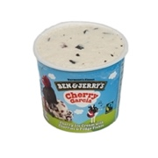
Option 5: Ben & Jerry’s Chocolate Chip Cookie Dough Ice Cream Cup | Ben & Jerry’s chocolate chip cookie dough flavored ice cream. 4 oz. | $3.50 ea

_____Option 1: Bomb Blast popsicles for at $2.00 each.

_____Option 2: Blue Bunny Ice Cream Sandwich Chips Galore for at $3.00 each.

_____Option 3: Ice Cream Floats for at $4.00 each.

_____Option 4: Ben & Jerry’s Cherry Garcia Ice Cream Cup (4 oz) for at $3.50 each.

_____Option 4: Ben & Jerry’s Cookie Dough Ice Cream Cup (4 oz) for at $3.50 each.

Total amount due:

Unit: Week: Campsite:

Select night of cracker barrel: Monday Tuesday Wednesday Friday

Point of contact:

Email: Phone:

Payment Options: Cash, Check, Credit Card Pay in person at the Headquarters Building

